INFM 219 – BI Data Project – Professor Hatton helpful notes
In this assignment you will work to modify data that has been loaded from a data warehouse using the Excel Power Query (Power Pivot) tool. The steps you will take are part of ensuring data quality when creating visualizations. Parts 1 and 2 use Microsoft Excel, parts 3 through 5 use Power BI Online.

Part 1 – Import tables and create the data model (30 points)
The instructions for part 1 and 2 are written for Office 365 that can be downloaded from Ivy Tech.
- Download the file “SalesData.zip” from the assignment in IvyLearn and extract the CSV files.
- Open Microsoft Excel and create a blank workbook
- Go to the “Data” menu and select “Manage Data Model” from the “Data Tools” section
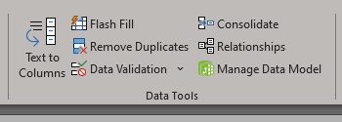

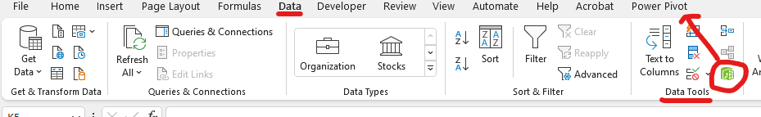
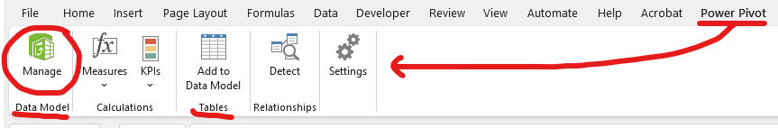
- From the “Get External Data” section on the ribbon, select “From Other Sources” to begin the import. These files are from the data warehouse that has been created based on the data from the Module 1 assignment.

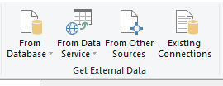
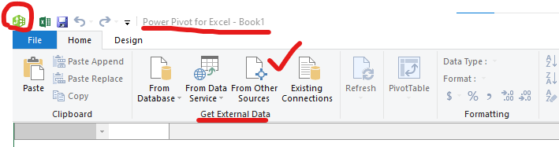

Scroll to the bottom of the list and select “Text File” then click the “next” button. Browse for the “DimensionDate.csv” file you downloaded and select “Open” to load file. Check the box “Use first row as column headers” to make sure the file loads correctly, name the table Date by removing “Text Dimension” from the name.

Review the data, then click “Finish” to continue. Once the first one loads, do the same for each of the other files. When you are finished with the import, you will see 6 tabs at the bottom of the Power Query screen; City, Customer, Date, Employee, Stock Items, and Sale.

- SAVE DOCUMENT

- Once all the tables are created, click “Diagram View” from the “View” section of the ribbon to review the data model. You need to create relationships from each of the dimension tables to the fact tables which will be represented using a star schema. To Create the relationships, drag the column from the fact table to the appropriate dimension table column. See screenshots next page.
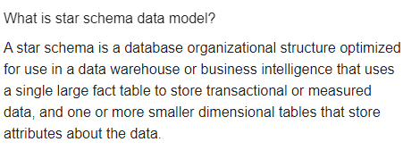
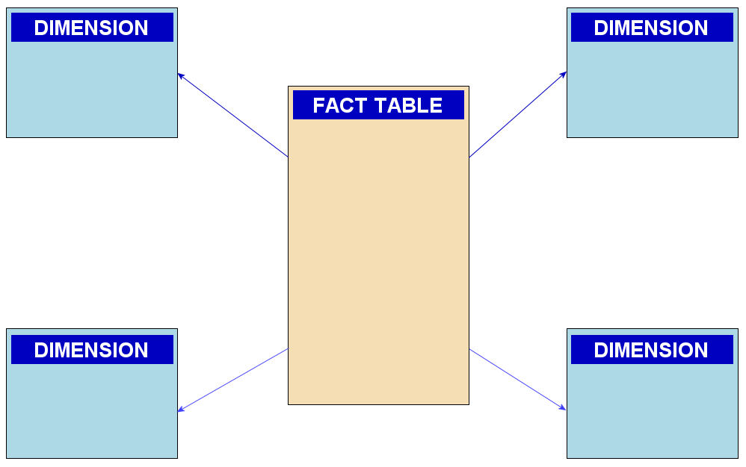

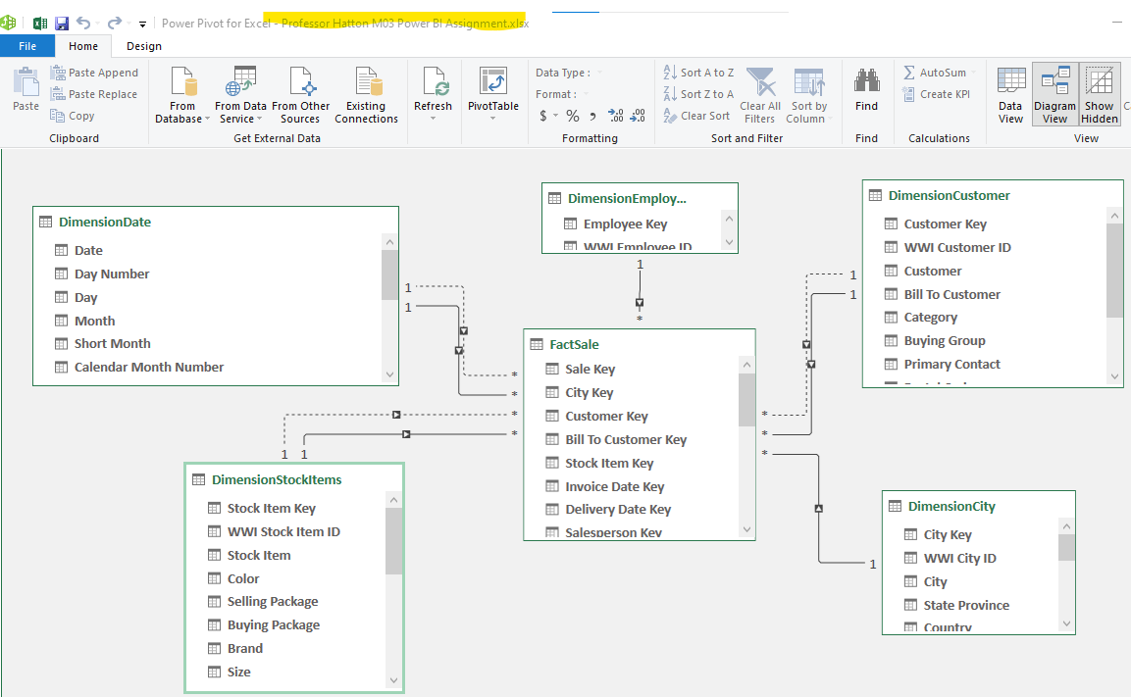
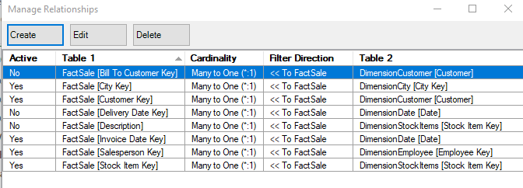

Part 2 – Data Formatting (30 points)
- Return to the “Data View” so you can see the data. Notice on the bottom of the screen that there are six tabs representing each table name from the data model.
- Modify the formatting for each of the listed columns based on the information in the table below.
Table Name | Column Name | Formatting Modifications
City | Latest Recorded Population | Format as whole number
Employee | Is Salesperson | Change data type to TRUE/FALSE
Stock Items | Is Chiller Stock | Change data type to TRUE/FALSE
 | Recommended Retail Price | Change data type to Currency
Sale | Invoice Date and Delivery Date | Remove the time from the date
 | Total Including Tax | Change the data type to Currency
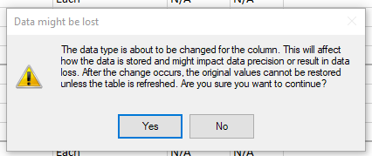
- We need to modify the “Tax Rate” columns on both the Sale and Stock Item tables so they are displayed as a percentage; however, you cannot directly modify the column and will need to make a new calculated column.
Go to the last column on the “Stock Item” table and select the first row in “Add Column” to accomplish this task.

In the formula bar type the following formula and click the checkmark. You will see a new “Calculated Column 1” created with the values expressed as decimals.

=[Tax Rate]/100

Rename the column “Tax Percent” by right-clicking and choosing “Rename” from the menu.
Format the data as a percentage with 1 decimal, then do the same for the “Tax Rate” column in the “Sale” table as well.
- Hide both “Tax Rate” columns by right-clicking and selecting “Hide from Client Tools”. You will still be able to see the column in the data model unless you unselect “Show Hidden” from the “View” menu. This just prevents the table from being displayed in Excel.
- Add another calculated column with the name “Sale Total” using the formula below. This allows us to use the newly created “Tax Percent” column to validate the number shown in the column “Total Including Tax” verify the numbers match after creating the column.
=[Total Excluding Tax]*[Tax Percent]+[Total Excluding Tax]
- Format the new column as currency and make any other formatting changes you think are needed.
- Hide the “Lineage Key” columns from each table.
- We need to enable the use of dedicated date filtering on reports. To accomplish this, select the “Date” table tab and chose the option “Mark as Date Table” from the “Calendars” section. Chose an appropriate column to use as a unique identifier based on the instructions shown on the screen.
- Close Power Query from the “File” menu, you will then be brought back to a blank Excel worksheet. Save the Excel workbook as “Sales Data Mart”
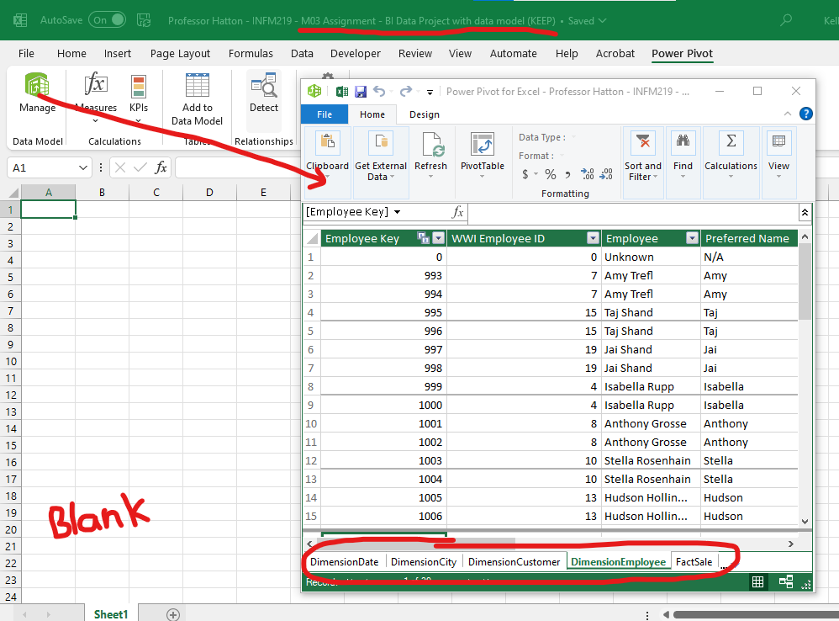

Part 3 – Load Data to Power BI (10 points)
In the next assignment parts, you will be working with the dataset using Power BI. Refer to the assignment “Power BI: Dashboards for Beginners” and “Create an Interactive Report” in Module 1 if you need a refresher on Power BI.
- Go to https://powerbi.com and sign-in using your Ivy Tech credentials.
- From the Power BI web interface select “My workspace” from the navigation menu on the left, click “New” and “DataSet“ “semantic model” then upload your Excel workbook.
- Chose the option to import the file into Power BI, once the import is complete you will have a new dataset named “Sales Data Mart” that contains all the information from your Excel workbook.

Part 4 – Use Power BI to Create a Dashboard (40 points)
For this next part you need to create a dashboard to meet the following requirements. You are free to format the dashboard any way you want, just make sure the data is easy to read and is accurate. Once you create the dashboard you will need to answer the questions in part 5 of this assignment correctly.

Page 1 (30 points)
- Create a chart to show the profit by each employee for fiscal years 2018-2020.
  - You will filter on fiscal year.
  - All employees are listed in the database, so you will need to filter for only salespersons.
- Create a chart to show the top 10 cities by “Total Excluding Tax” from the Sale table.
- Create a chart to show the bottom 10 cities by “Total Excluding Tax” from the Sale table.
- Create a chart to show the quantity of items sold by sales territory.

Page 2 (10 points)
- Create a chart showing the 10 least profitable items for FY 2020.
- Create a chart showing the 10 most profitable items for FY 2020.
When you have finished your dashboards, export them to a PDF file for submission.

Part 5 – Answer Questions from the Data (10 points)
- Who is the most profitable salesperson for FY 2020 and what is their total profit? Sofia Hinton and she sold $2,897,708.05
- What is the name of the city with the highest sales (excluding sales tax)and what is the total? Akinok $502,494
- What are the total sales (excluding sales tax) for the city of Fulton? I couldn’t find it my data wuldnt display pasy blackbird
- What is the percentage of sold quantity for the Mideast sales territory (for FY 2018-2020)? 15.70%
- How much profit did Jack Potter generate for FY 2019? $2,652,325.90
- Are Jack Potter’s profits higher or lower for FY 2020? Higher
- What is the product with the most negative profit for FY 2020? Yellow packing knife with inserts
- What is the product with the most amount of profit for FY 2020? 20mm double sided bubble wrap 50mm
- What is the total profit for 20mm anti-static bubble wrap (blue) 20m? $2,427,550
- What is the total profit for superhero action jacket (blue) XXS? $33,864

